DEBIT CARD ORDER FORM

Member name: Click or tap here to enter text.
Business Name (Optional): Click or tap here to enter text.
Date: Click or tap here to enter text.
Account Number:Click or tap here to enter text.
Card Style: CARD OPTIONS
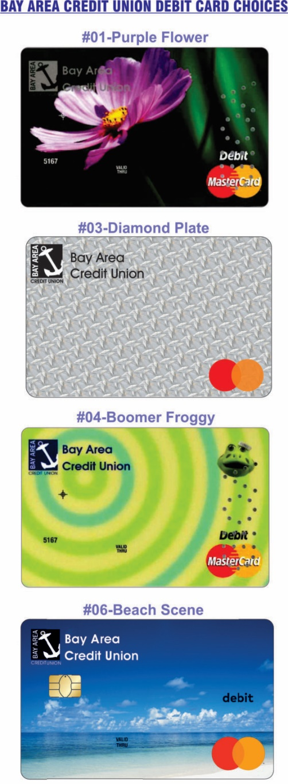
Indicate which accounts to be associated with this debit card:
☐ PRIMARY SAVINGS ACCOUNT
☐ SECONDARY SAVINGS ACCOUNT
☐ PRIMARY CHECKING ACCOUNT

